

**Data Technician**

|  |
| --- |
|  |

|  |
| --- |
| Name: |
| Course Date: |
|  |

**Table of contents**

Day 1: Task 1 3

Day 1: Task 2 3

Day 1: Task 3 4

Day 2: Task 1 5

Day 3: Task 1 9

Day 3: Task 2 10

Day 3: Task 3 11

Day 4: Task 1 12

Day 4: Task 2 13

1. Scenario Background 13

2. Data Laws and Regulations 14

3. Azure Service Recommendations 14

4. Data Types and Data Modelling 14

5. Data Storage Formats and Structures in Azure 14

6. Additional Considerations 15

Submission Guidelines: 15

Course Notes 17

Additional Information 17

# Day 1: Task 1

Please research and complete the below questions relating to key concepts of cloud.

Be prepared to discuss the below in the group following this task.

|  |  |
| --- | --- |
| What can cloud computing do for us in the real-world? | Cloud computing has become a very important component of the modern era and has multiple real-world applications that have made it a crucial tool. One of the real-world applications of cloud computing is the infrastructure for things such as cloud storage this allows for users to store data not on physical hard drives but on the cloud, which is far more scalable it offers people the ability to purchase storage larger than a physical hard drive without occupying any physical space. |
| How can it benefit a business? | It can benefit a business because some businesses may not be able to afford their own servers this allows them to fulfil their needs at a cheaper cost. Also the business can easily scale up in a way physical servers cannot. |
| What’s the alternative to cloud computing? | The alternative to cloud computing would be to have your own infrastructure setup servers etc. it has it’s advantages of not being reliant on another company but it can be costly and hard to scale. |
| What cloud providers can we use, what are their features and functions? | The main cloud providers we can use are google cloud platform(gcp) Microsoft azure and amazon web services and they have features and functions such as cloud storage virtual computing serverless computing etc. |

# Day 1: Task 2

Please research the below cloud offerings, explain what they are and examples of use cases.

|  |  |  |
| --- | --- | --- |
| Cloud Offerings | Explain what it is | When / how might you use this service in the real-world? |
| IaaS (Infrastructure as a service) | Infrastructure as a service is when computer infrastructure such as storage and servers is rented out. | This would be used in the real world as a business that does not want physical servers for their own network so they’d pay for this service so that they possess the infrastructure but not have to physically maintain it. |
| PaaS (Platform as a service) | Platform as a service is when the platform is rented out an example of this is google cloud engine hosting web applications. | This would be used in the real world when people need a platform but want to create their own software an example would be google cloud engine it provides the business with the necessary infrastructure to create a web application this could be very convenient to businesses. |
| SaaS (Software as a service) | Software as a service is when software like office suite for example is rented out. | This could be used in the real world as a company could hire office suite for their employees they pay Microsoft for the ability to use their software and they can then reap the benefits of it |

# Day 1: Task 3

Please research the below terms and explain what they are, when they would be appropriate and a real-world example of where it could be implemented (i.e. what type of organisation).

|  |  |
| --- | --- |
| Public Cloud | Public cloud is a cloud environment where the resources are shared publicly these cloud environments are provided by third party providers over the internet examples include Azure AWS and GCP these offer scalability with pay as you go pricing. |
| Private Cloud | A private cloud on the other hand is a cloud environment that is reserved for a single organization hosted either on premises or by a third-party provider it offers the same benefits as public cloud with the added benefit of security. An example would be a private company that needs to keep sensitive data secure |
| Hybrid Cloud | Hybrid cloud combines both public and private cloud environments it allows data to move between the two effortlessly and it has the scalability of a public cloud with the security of a private cloud. An example would be a company that has a private facing side and keeping sensitive data in a private cloud. |
| Community Cloud | A community cloud is infrastructure that is shared within a group or organization with the same security needs and compliance requirement it balances the cost of public clouds with the customization of private clouds. An example would be a non-profit sharing data to their community members. |

# Day 2: Task 1

Describe, with examples, the **three** major areas that the Computer Misuse Act deals with.

|  |  |  |
| --- | --- | --- |
| Area | Description | Example |
| Unauthorized access to computer material | Gaining access to a computer system without permission known as hacking this is just the act of hacking not any criminal intent that follows. | An example could be someone guessing someone’s password and reading their emails violating their privacy. |
| Unauthorized access with the intent to commit or facilitate crimes | This is when someone hacks a computer system with the intent to commit a crime after. | Hacking a e commerce company with the goal of stealing credit card information |
| Unauthorized acts with intent to impair or cause serious damage. | This is when someone hacks with the goal of causing damage e.g. deleting data. | A disgruntled employee deleting records from their former workplace database. |

The computer misuse act 1990 is an act where an individual can be criminalised because of computer related offense. Describe three extra powers that the Police and Justice Act 2006 (Computer Misuse) has added.

|  |
| --- |
| Description |
| Making or sharing hacking tools illegal: It became a crime to make sell or get tools if you plan to break into computers with them even getting you up to 7 years in jail. |
| Harsher punishment for unauthorized access: the punishment for breaking into someone’s computer became more punitive increasing to up to 2 years |
| Expansion of unauthorized acts to include reckless impairment: this means even if you didn’t mean to destroy data there is still a punishment for your actions. |

Look at the below website to answer the questions:

<https://www.gov.uk/personal-data-my-employer-can-keep-about-me>

|  |
| --- |
| Write down three items of data which a company can store about an employee. |
| Name: companies can store employees name for payroll or contact purposes. |
| Address: companies can store an employee address for contact purposes. |
| Work contact details: companies can store phone numbers for contact etc. |

|  |
| --- |
| Give three more examples of data that an employer can only store if they first get the employee’s permission. |
| Health information: things such as medical conditions disability status so that employers can know employees are telling the truth if they have conditions that affect work. |
| Bank account details: these are added to company payroll so employees can receive their pay checks without hassle but it requires permission. |
| Whether an employee is a member of a trade union this information can only be collected if the employee consents to it. |

Conduct further research to answer the below questions.

|  |  |
| --- | --- |
| Question | Answer |
| Provide one example of: Copyright infringement | An example of copyright infringement would be someone making a version of a movie when they do not have the permission of the copyright owner they are infringing on their intellectual property. |
| Provide one example of: Plagiarism | An example of plagiarism is attempting to pass off work that isn’t yours as your own e.g. a college student. |
| What are two consequences of copyright infringement and software piracy? | Legal penalties such as fine or imprisonment e.g. someone is fined for infringing on copyright or lawsuit by the copyright owner. |
| Give three possible consequences for individuals when using pirated software | Someone could face legal action from the software owner. Someone could be risking a virus or malware downloading unverified software. Someone could lose their job If their employer finds out they are pirating software. |

Listed below are some laws which we have covered today:

1. Computer Misuse Act 1990

2. Police and Justice Act 2006 (Computer Misuse)

3. Copyright, Designs and Patents Act 1988

4. Copyright (Computer Programs) Regulations 1992

5. The Health and Safety (Display Screen Equipment) Regulations 1992

6. Data Protection Act 2018

7. Consumer Rights Act 2015

* Insert a number in the first column of each row to match each of the statements with one of the above Acts.
* One of statements is incorrect and not illegal. For this statement, write ‘Not illegal’.

|  |  |
| --- | --- |
| **Act number** | **Clause** |
| 3 | With some exceptions, it is illegal to use unlicensed software |
| 7 | Any product, digital or otherwise, must be fit for the purpose it is supplied for |
| 1 | Unauthorised modification of computer material is illegal |
| Not Illegal | It is illegal to create or use a hacking tool for penetration testing |
| 6 | Personal data may only be used for specified, explicit purposes |
| 5 | Employers must provide their computer users with adequate health and safety training for any workstation they work at |
| 2 | It is illegal to distribute hacking tools for criminal purposes |
| 3 | It is illegal to distribute an illicit recording |
| 6 | Personal data may not be kept longer than necessary |
| 1 | Gaining unauthorised access to a computer system is illegal |
| 5 | Employers must ensure that employees take regular and adequate breaks from looking at their screens |
| 1 | It is illegal to prevent or hinder access (e.g. by a denial-of-service attack) to any program or data held in any computer |
| 6 | Personal data must be accurate and where necessary kept up to date |

# Day 3: Task 1

Please complete the below lab (3) *‘Explore relational data in Azure’* and paste evidence of the completed lab in the box provided.

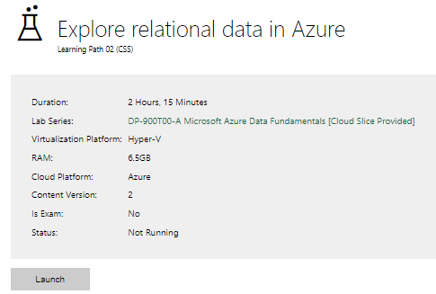

|  |  |
| --- | --- |
| Completed lab |  |

# Day 3: Task 2

Please complete the below lab (4) *‘Explore non-relational data in Azure’* and paste evidence of the completed lab in the box provided.

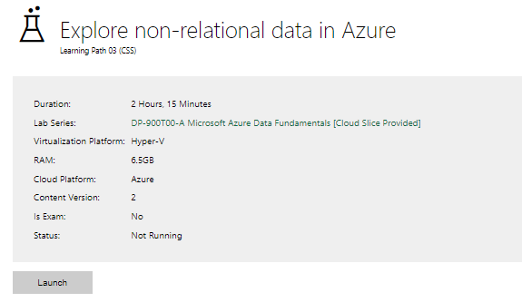

|  |  |
| --- | --- |
| Completed lab |  |

# Day 3: Task 3

Please complete the below lab (5) ‘Explore data analytics in Azure’ and paste evidence of the completed lab in the box provided.

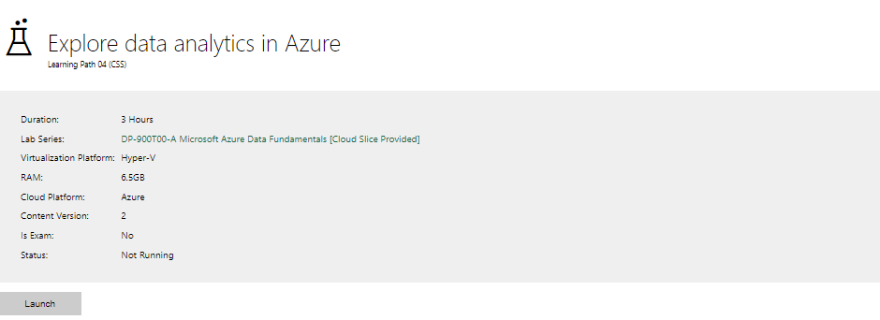

|  |  |
| --- | --- |
| Completed lab |  |

# Day 4: Task 1

In your teams, complete the Azure DP-900 practice exam and paste your result below – this is open book and please research and discuss your answers as a team.

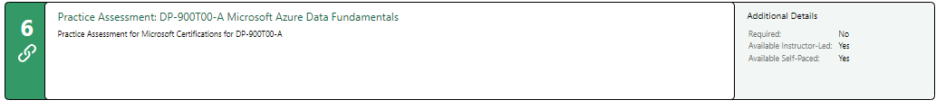

|  |  |
| --- | --- |
| Result |  |

# Day 4: Task 2

#### **1. Scenario Background**

"Paws & Whiskers" is a growing pet shop that aims to improve its business by analysing sales, customer information, and inventory data. Currently, the data is collected manually or stored in spreadsheets. Management is interested in transitioning to Microsoft Azure to streamline data storage, analysis, and reporting, enabling them to make data-driven decisions.

#### **2. Data Laws and Regulations**

Identify and explain the data laws and regulations relevant to handling customer data within the proposal. Ensure you cover the following points:

* **GDPR Compliance**: Highlight the importance of adhering to the General Data Protection Regulation (GDPR), particularly as it relates to storing and processing customer information.
* **Data Protection Act (DPA) 2018**: Outline how the DPA 2018 may affect the way "Paws & Whiskers" collects and stores data, ensuring compliance with UK laws on data privacy.
* **Other Industry Standards**: Research any additional data protection standards or regulations that may apply to pet shop data, particularly if they involve sensitive or payment information.

#### **3. Azure Service Recommendations**

Recommend Microsoft Azure services that would suit the company’s data analysis needs and explain why these services are suitable. Your recommendations should include:

* **Data Storage**: Identify suitable storage options, such as **Azure Blob Storage** or **Azure SQL Database**, and discuss the benefits of each for storing large datasets, including inventory, sales transactions, and customer details.
* **Data Analysis Tools**: Recommend tools such as **Azure Machine Learning** for customer behaviour analysis or **Azure Synapse Analytics** for analysing sales trends.
* **Data Integration and Automation**: Explain how services like **Azure Data Factory** could automate data collection and integration processes, improving efficiency.

#### **4. Data Types and Data Modelling**

Define the types of data "Paws & Whiskers" will need to work with and describe your approach to data modelling:

* **Data Categories**: Identify key data types, such as customer demographics, transaction history, pet inventory, and product categories.
* **Data Modelling Approach**: Outline how you would structure this data using a relational model or a data warehouse approach, considering factors like tables, entities, relationships, and primary keys.

#### **5. Data Storage Formats and Structures in Azure**

Discuss how you would store data within Azure and the formats you would recommend:

* **Data Formats**: Specify recommended formats (e.g., CSV for raw data imports, JSON for structured data, Parquet for analytics) and explain why these formats are suitable for specific data types.
* **Data Security and Encryption**: Include recommendations for securing data using Azure’s built-in encryption features and access controls to ensure compliance with data privacy regulations.

#### **6. Additional Considerations**

Provide any other considerations that might enhance data handling and efficiency in Azure, such as:

* **Backup and Disaster Recovery**: Outline a backup plan using **Azure Backup** or **Azure Site Recovery** to safeguard against data loss.
* **Data Visualisation**: Discuss potential use of **Power BI** within Azure for creating dashboards that provide management with real-time insights into sales and customer trends.
* **Future Scalability**: Comment on how Azure services can scale as the business grows, accommodating larger datasets and more complex analyses.

### **Submission Guidelines:**

1. **Structure**: Ensure your report is well-organised, with sections for each task (e.g., Data Laws, Azure Services, Data Types, etc.).
2. **Formatting**: Include headings, bullet points where appropriate, and any visuals or diagrams that support your explanations.
3. **References**: Cite any resources or regulations referenced in the report.
4. **Length**: Aim for 1500-2000 words.

|  |
| --- |
| Introduction: Paws and whiskers are making a smart move transitioning from manually storing and keeping track of their data to employing a service (Microsoft Azure) this has the benefit of being easier to scale less with less effort to maintain. During this essay I will be going in depth about this transition taking into consideration the data laws that the company will need to abide by the azure services I would recommend the data types and data modelling they could use the storage and structures in azure and any additional considerations that could be made.  Data laws: The handling of data is one of the most important aspects to be taken into consideration during this migration. This is because there are many different laws and regulations that needs to be abided by in order to avoid the company potentially getting into trouble. One of the most important regulations is the General Data Protection Regulation (GDPR) the GDPR mandates that any personal data such as the customer name, addresses and payment details be processed with a lawful basis e.g. if the customer gives you their card details it should only be used to fulfil a purchase or if a customer gives you their address it should only be used to send them items. Customers can also access amend or erase their data this requires a streamlined process so that any requests can quickly be fulfilled. Another important aspect of GDPR is data minimization this means that only the essential data can be collected from the customer. Security measures need to be implemented to fulfil the GDPR requiring encryption and access controls to safeguard data. Refusing to comply with the GDPR can result in a fine of either 4% of annual turnover or 20 million euros this shows how crucial it is for the company to adhere to it during the transition to Microsoft azure.  Another law that is important to take into consideration for Paws and Whiskers is the Data Protection Act (DPA) this act along with the GDPR sets the legal framework for data protection in the UK and as such any business is expected to comply with it. The act has many of the same requirements. To adhere to this law Paws and whiskers must ensure that accountability is maintained by documenting all of its data activities and if there is large scale data processing occurring then they will need to hire a dedicated data officer to ensure that any data breaches are reported. Other regulations that apply to the pet shop in regards to data include the Payment Card Data Security Standard (PCI DSS) this applies to the data made on payments so any payments must be encrypted and cardholder information must have restricted access. Also, because it is a pet shop they will need to comply with veterinary regulations in regards to things such as pet health data knowingly selling a sick pet can also violate consumer protection laws. These are the general regulations paws and whiskers must abide by if they want to transition to azure.  Azure Services: There are many services that are available on the Microsoft azure platform that can be perfect for the needs of the pet shop including features for data storage data analysis and automation. For the pet shop’s data storage needs Azure SQL database is perfect for storing structured datasets like customer profiles, sales/transactions and inventory records. The positive part of this relational database service is its scalability it allows for storage of terabytes of data whereas an excel spreadsheet is limited to 1 million rows it also possesses built in encryption something that can help the company to comply with GDPR and SQL queries that can help the company gain insight into any interesting trends. Azure blob storage can also be utilized for unstructured or semi structured data examples of this can be photographs of the pets or other inventory scanned invoices or legacy spreadsheets. The benefits of blob storage is that there are different versions for different price points all customers are not locked into paying the same prices for features that they do not need or will not use the different tiers are named hot cool and archive. Another azure service that can suit the companies needs is azure synapse analytics this would benefit the pet shop because they could uncover sales trends and inventory patterns allowing them to optimize where necessary e.g. stocking a popular chew toy that keeps selling out. This is done through the integrated analytics service which combines data warehousing and big data processing. If they want in depth analysis on their customers behaviour azure machine learning can help them with its predictive capabilities allowing them to stock up on items if the algorithm determines they will be popular. Another azure service that can benefit the pet shop is azure data factory it will allow them to streamline data collection and integration reducing the burden of doing it manually. This service orchestrates data pipelines pulling information from different sources like online orders and spreadsheet and pooling them into the unified azure environment. Because this service is automated it offers efficiency the manual service doesn’t.  Data Types: The data that paws and whiskers contains can span many different categories one of which could be customer information such as name, home address, email, number and contact preferences. Another category could be transactions containing purchase date amount purchased for the item that was purchased and customer loyalty points. Another category could be inventory data such as the amount of stock the supplier that product comes from and a product description this could be useful because the products that are low on stock must be popular so you can increase availability to increase sales this is how the data can benefit the company. A relational database model using azure SQL database suits the business’s structured data needs an example of possible tables could be customers containing (customerid, name, email) transactions containing( transactionid, customerid, date, amount) inventory containing( productid, name, email) the primary keys being customerid and productid to ensure uniqueness while the foreign keys such as customerid in transactions establish relationships between the different tables.  Data Storage and formats: It is very important to choose the right storage format and security measures for performance reasons also compliance reasons. For raw data imports like ones from the spreadsheets the pet shop had previously been using csv files offer simplicity and compatibility making them ideal for initial uploads to azure blob storage structured data like customer or transaction records on the other hand benefit from json which supports hierarchical relationships and integrates well with azure SQL database. Parquet is also useful for analytical insights it allows for enhanced query speed and doesn’t take up loads of space which is useful for large datasets.  Security is paramount given the regulations the pet shop has to abide by. Azure contains built in encryption at rest and in transit to protect against unauthorized access this fulfils GDPR DPA and PCI DSS requirements. Role based access control restricts data to authorized personnel this adds a layer of security as information that only the manager should see is seen by the manager. Azure key vault can store encryption keys securely whilst it’s VPN service makes sure that the data is confined to the internal network.  Additional Considerations: Beyond the basic functionality explained above there are several enhanced features which can enhance the pet shop’s azure deployment. Backup and disaster recovery are crucial in any modern business Azure backup offers automated snapshots of SQL databases and blob storage with customisable retention periods to balance cost and recovery needs. This means that if there is a disaster or accident the owners of the pet shop can be sure that backups exist. Azure site recovery works with this by replicating data across regions ensuring business continuity if something happens to the primary data centre. These measures both protect against disruptions and allow the regulatory expectations for data integrity to be met.  For real time insights combining Power BI with Azure allows you to transform your data into interactive dashboards this can be incredibly beneficial because it allows management to see trends and patterns and utilize this to grow the business an example of this is a popular item at the pet shop if the dashboard shows how popular it is it can allow the pet shop to order it in bulk catering to their customers. Also they can see who their more loyal customers are and target them more aggressively there is a saying in business the 80/20 rule that 20 % of your customers are responsible for 80% of your profits this allows you to cater to your main customers. Another benefit is with services like Azure SQL there is a higher level of scalability this means that the growth potential for your business is no longer finite and the money involved is more economical. An example of this is extra features during one time of the year you can just set autoscaling to scale up future proofing your growth strategy.  References:  European Commission. (2016). Regulation (EU) 2016/679 - General Data Protection Regulation (GDPR). Retrieved from https://eur-lex.europa.eu/eli/reg/2016/679/oj  UK Government. (2018). Data Protection Act 2018. Retrieved from https://www.legislation.gov.uk/ukpga/2018/12/contents/enacted  PCI Security Standards Council. (2022). PCI DSS v4.0. Retrieved from https://www.pcisecuritystandards.org/document_library  Microsoft. (2023). Microsoft Azure Documentation. Retrieved from https://learn.microsoft.com/en-us/azure/  International Organization for Standardization. (2022). ISO/IEC 27001:2022 - Information Security Management. Retrieved from https://www.iso.org/standard/27001 |

|  |
| --- |
| **Course Notes** |

It is recommended to take notes from the course, use the space below to do so, or use the revision guide shared with the class:

|  |
| --- |
| **Additional Information** |

We have included a range of additional links to further resources and information that you may find useful, these can be found within your revision guide.

**END OF WORKBOOK**

**Please check through your work thoroughly before submitting and update the table of contents if required.**

**Please send your completed work booklet to your trainer.**